**1.**

<!DOCTYPE html>

<html>

<head>

<body style="background-color:yellow;">

<h1 style="background-color: orangered;">This is a heading</h1>

<p style="background-color:green;">This is a paragraph</p>

</body>



**2.**

<!DOCTYPE html>

<html>

<body>

<h2>Image as a Link</h2>

<p>The image below is a link. Try to click on it.</p>

<a href="https://www.w3schools.com/html/default.asp"><img src="https://image.shutterstock.com/image-vector/smiley-vector-happy-face-260nw-465566966.jpg" alt="HTML learn" style= "border: 1px solid purple;  width:42px;height:42px;"></a>

</body>

</html>



<!DOCTYPE html>

<html>

<body>

<h2>Image as a Link</h2>

<p>The image below is a link. Try to click on it.</p>

<a href="https://www.w3schools.com/html/default.asp"><img src="https://image.shutterstock.com/image-vector/smiley-vector-happy-face-260nw-465566966.jpg" alt="HTML learn" style= "width:42px;height:42px;"></a>

</body>

</html>



**3.**

<html>

<head>

    <style>

        table,

        th,

        td {

            border: 1px solid black;

        }

    </style>

</head>

<body>

    <b>One column:</b>

    <table>

        <tr>

            <td>100</td>

        </tr>

    </table>

    <b>One row and three columns:</b>

    <table>

        <tr>

            <td>100</td>

            <td>200</td>

            <td>300</td>

        </tr>

    </table>

    <b>Two row and three columns:</b>

    <table>

        <tr>

            <td>100</td>

            <td>200</td>

            <td>300</td>

        </tr>

        <tr>

            <td>400</td>

            <td>500</td>

            <td>600</td>

        </tr>

    </table>

</body>

</html>

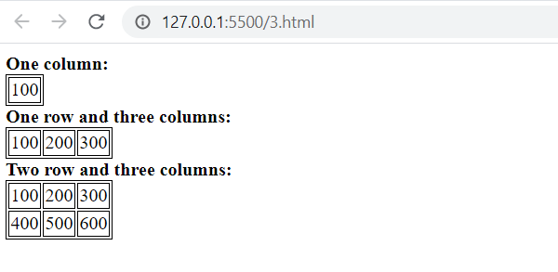

**4.**

<html>

<head>

    <style>

        #table-a,td {

            border: 1px solid;

        }

        #table-b td {

            border: none;

        }

    </style>

</head>

<body>

    <b>table with border:</b>

    <table id="table-a">

        <tr>

            <td>100</td>

            <td>200</td>

            <td>300</td>

        </tr>

        <tr>

            <td>400</td>

            <td>500</td>

            <td>600</td>

        </tr>

    </table>

    <b>table with no borders:</b>

    <table id="table-b">

        <tr>

            <td>100</td>

            <td>200</td>

            <td>300</td>

        </tr>

        <tr>

            <td>400</td>

            <td>500</td>

            <td>600</td>

        </tr>

    </table>

</body>

</html>

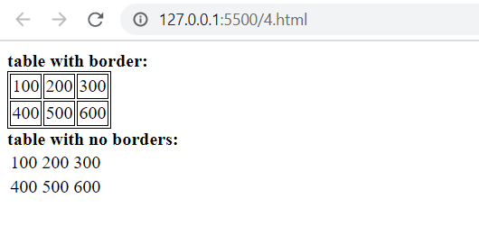

**5.**

<!DOCTYPE html>

<html>

<body>

<h2><b>Numbered list:</b></h2>

<ol>

  <li>Apples</li>

  <li>Bananas</li>

  <li>Lemons</li>

  <li>Oranges</li>

</ol>

<h2><b>Letters list:</b></h2>

<ol type="A">

  <li>Apples</li>

  <li>Bananas</li>

  <li>Lemons</li>

  <li>Oranges</li>

</ol>

<h2><b>Lowercase letters:</b></h2>

<ol type="a">

  <li>Apples</li>

  <li>Bananas</li>

  <li>Lemons</li>

  <li>Oranges</li>

</ol>

<h2><b>Roman numbers list:</b></h2>

<ol type="I">

  <li>Apples</li>

  <li>Bananas</li>

  <li>Lemons</li>

  <li>Oranges</li>

</ol>

</body>

</html>

<h2><b>Lowercase Roman numbers list:</b></h2>

<ol type="i">

  <li>Apples</li>

  <li>Bananas</li>

  <li>Lemons</li>

  <li>Oranges</li>

</ol>

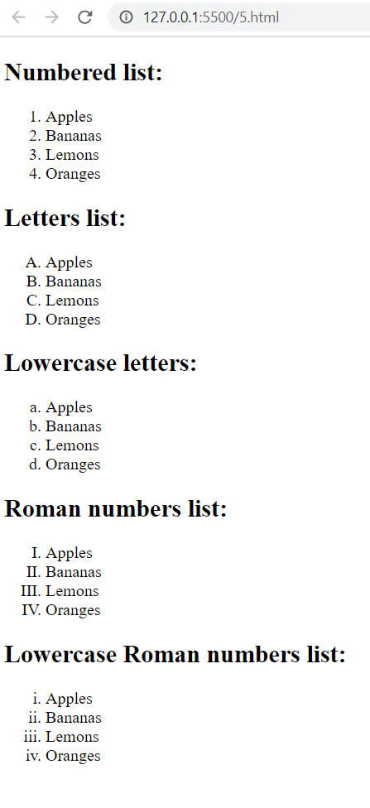

**6.**

<!DOCTYPE html>

<html>

<body>

<form>

  <label for="username">Username:</label><br>

  <input type="text" id="username" name="username"><br>

  <label for="pwd">Password:</label><br>

  <input type="password" id="pwd" name="pwd"><br><br>

  <input type="submit" value="Submit">

</form>

</body>

</html>

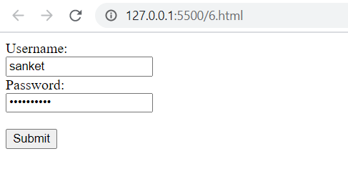

**7.**

<!DOCTYPE html>

<html>

<body>

<form>

  <input type="checkbox" id="vehicle1" name="vehicle1" value="Bike">

  <label for="vehicle1"> I have a bike</label><br>

  <input type="checkbox" id="vehicle2" name="vehicle2" value="Car">

  <label for="vehicle2"> I have a car</label><br><br>

  <input type="submit" value="Submit">

</form>

</body>

</html>



**8.**

<!DOCTYPE html>

<html>

<head>

<style>

table, th, td {

  border: 1px solid black;

  border-collapse: collapse

}

td {

  padding-top: 15px;

  padding-right: 15px;

}

th {

  text-align: left;

}

table{

    margin: auto;

}

</style>

</head>

<body>

<table>

  <tr style="background-color:#008080">

    <th colspan="2">top</th>

  </tr>

  <tr>

    <td style="background-color:#808080">left</td>

    <td style="background: color #c0c0c0;">right</td>

  </tr>

</table>

</body>

</html>



**9.**

<!DOCTYPE html>

<html>

<head>

<style>

table, th, td {

  border: 1px solid black;

  border-collapse: collapse

}

th {

  text-align: left;

}

table{

    margin: auto;

}

</style>

</head>

<body>

<table>

    <tr>

    <td style="background-color:#C0C0C0;">topleft</td>

    <td style="background-color: #808080;">topright</td>

  </tr>

  <tr>

    <td style="background-color:#808080; padding-top: 15px;">botleft</td>

    <td style="background-color: #C0C0C0; padding-top: 15px;">botright</td>

  </tr>

</table>

</body>

</html>

